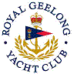 | Royal Geelong Yacht Club Inc.  Est 1859
Trophy Deed of Gift.

Trophy: | Hitchcock Perpetual Shield
Presented by: | Howard Hitchcock O.B.E., J.P.
Date: | 1922
For: | Season Aggregate
Remarks / Revisions | First winner: E.W.M (R. Burns) 1921  Reallocated: Div. 1 Aggregate
Click here to View Recipients

To read about the Hitchcock connection, click here.

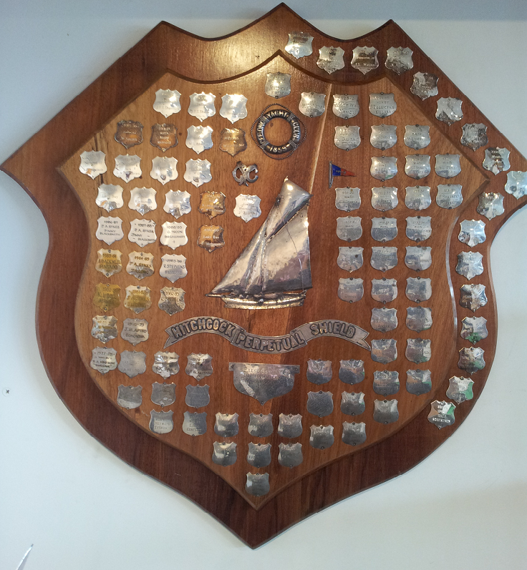

HOWARD HITCHCOCK. (1866-1932), businessman and civic leader, was born on 31 March 1866 at Geelong, Victoria, son of George Mitchelmore Hitchcock and his wife Annie, (nee Lowe). He was educated at Flinders State School and private schools before beginning at 18 as an assistant in the family firm of Bright & Hitchcocks, drapers. Five years later he became a junior partner, on his father's death in 1912 he took over as managing director. In 1926 he sold the business to five of his employees.
Hitchcock's interests turned outside Geelong when he espoused William Calder's proposal for the establishment of the Great Ocean Road as a memorial to the soldiers of the Western District. He became president of the Great Ocean Road Trust in 1918; he gave nearly £3000 to its appeal and it was his enthusiasm and energy as much as anything that kept the project afloat He died before he was able to open the completed road in 1932; in tribute, his car was driven behind the governor’s in the procession along the road on opening day.
In 1923 Hitchcock embarked on his third trip abroad and was absent for nearly three years. On his return, he was met by a cavalcade of cars at the outskirts of the town and escorted to a huge civic reception .In June 1925,in his absence, he had been elected member for South Western Provence in the Legislative Council. In 1931 he resigned all public positions because of ill health. He died of heart disease on 22 August 1932, survived by his wife Charlotte Louisa Turnbull, nee Royce, whom he had married on 16 April 1890; they had no children. He was buried in Eastern cemetery after a funeral service at the Wesleyan Church. His estate was valued for probate at £71,276.

